2024 Summer Packet

Grade Level:
Students Entering 1st Grade

Due: August 16, 2024
*5 points deducted for each day the packet is late.

School Motto: "Commit to the challenge."
School Vision: "Moving from good to great."
School Mission: "Marbut Traditional Theme School offers each student a challenging educational environment where self- discipline and high academic expectations are emphasized. Teachers, parents, and the community share the responsibility of promoting achievement and success for all."

ABOUT THE MARBUT THEME SCHOOL 1ST GRADE SUMMER PACKET

Dear Parent,
Summer is a great season to take advantage of the extra time you have to participate in learning with your child. This Summer Packet is a required component of the Theme School program. Most of the activities focus on “learning by doing” which is the hallmark of early learning experiences for every child. It is also an ideal opportunity for your child to get a head start on various skills taught in the first grade.

The packet is designed to be self-managed. Complete all the activities with your child. It may be helpful to review the rubric for each area before doing the assignments. The rubrics are enclosed to give you a clear picture of how your child's work will be graded.

ORGANIZING AND GRADING
A spiral notebook is required for your child to use as a Summer Journal. All activities that require a written response should be recorded in the journal. Other activities should be stapled and placed inside the spiral notebook.

Your child will earn points for each assignment. The points will be totaled and a final grade will be award in the following subjects: English/Language Arts, Mathematics, Science and Social Studies. Please make sure your child's journal is organized, neat, and accurate. This will help your child get off to a GREAT start in first grade.

DUE DATE
Please return this page along with the Summer packet activities Friday, August 16, 2024. No late projects will be accepted! We are preparing our kids for the future and adhering to deadlines is important.

Enjoy a sensational summer of learning and fun. We look forward to working with you and your child!

SIGNATURES REQUIRED
I worked with my parents to complete the summer activities:

______________________________________________
(child's signature)

I worked with my child to complete the Summer Packet:

______________________________________________
(parent's signature)

Dear Parents,

Attached is the first grade summer packet. This packet includes 2 choice boards. For each choice board, students are given 9 assignments and are to choose three assignments for each choice board. The students MUST start with the middle square for the MATH Choice Board only. The students must choose 3 activities IN A ROW (as in tic-tac-toe). Students will complete a total of 6 activities. Students are welcomed to complete more than 3 assignments per choice board to receive extra practice.

Have fun!!

The First grade teachers

1st Grade Poem
“The Rose that Grew from Concrete”
By Tupac Shakur

The Rose That Grew From Concrete
Did you hear about the rose that grew
from a crack in the concrete?
Proving nature's law is wrong it
learned to walk without having feet.
Funny it seems, but by keeping its dreams, it learned to breathe fresh air.
Long live the rose that grew from concrete when no one else ever cared.

1st Grade
Reading List

Directions: In preparation for the 2024-2025 school year, students must 10 books from the list below (that’s 1 book a week) and complete a reading log for each book read.

- Pete the Cat Series (students can choose to read any book in this series).
- The Story of Ruby Bridges by Robert Coles
- National Geographic Kids Readers: Weather
- A Picture Book of George Washington Carver by David A. Adler
- Thunder Boomer by Shutta Crum
- I am Enough by Grace Byers.
- Crown by Derrick Barnes
- Natalie’s Hair Was Wild by Laura Freeman
- Firebird by Misty Copeland
- Izzy Gizmo by Pip Jones
- Trombone Shorty by Troy Andrews
- Nikki and Deja by Karen English
- We March by Shane Evans
- John Henry by Julius Lester
- Princess Grace by Mary Hoffman
- Hidden Figures by Margot Lee Shetterly
- A Change of Heart by Alice Walsh
- My Name is Truth by Ann Warren Turner
- Chocolate Me! By Taye Diggs
- The Snowy Day by Jack Ezra Keats

1st Grade Sight Words
Directions: Please use at least 10 sight words from the list below in a narrative story. Be sure to handwrite your story on lined paper and highlight the sight words used. 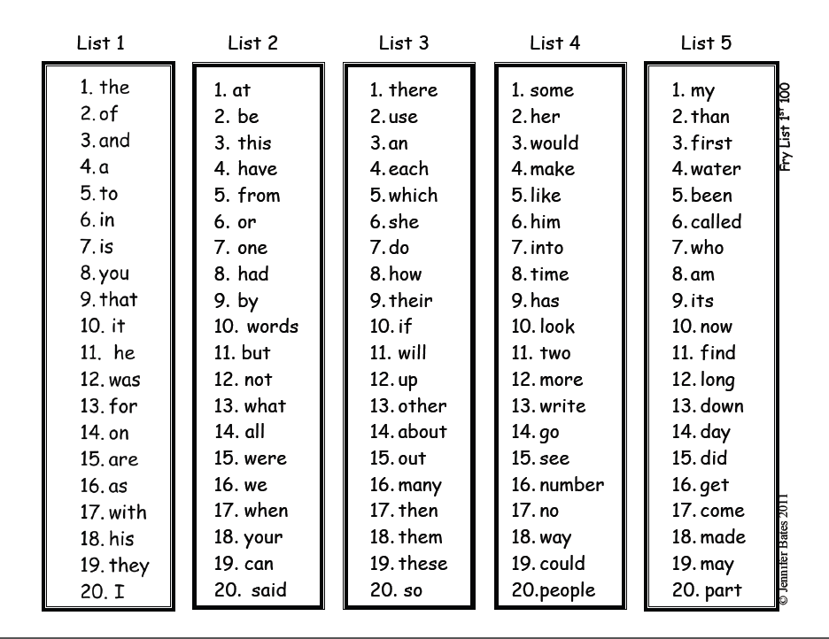

1st Grade

First Grade Science/Social Studies/Language Arts Choice Board
(Directions: Choose and complete THREE activities IN A ROW from the Math Choice Board below. You can complete more activities for extra credit.
YOU MUST START WITH THE MIDDLE SQUARE.)
Science / ELA  Choose an animal and create a book about the animal including the following details:  Cover page – Title and author  Page 1: A picture of the animal .  Pages 2 : A complete sentence about the animal’s shelter and one picture.  Pages 3: A complete sentence about the animal’s food and one picture.  Page 4: A complete sentence including one additional fact about the animal and a picture.  (Each picture must be hand drawn and colored by the student.) | Social Studies /ELA  Read a book about George Washington Carver. Create a sculpture of George Washington Carver. Use any combination of soap, wood, clay, sticks, wire, cloth, yarn, buttons, stones, old toy pieces, or any other object. Write 3 complete sentences and use adjectives to describe George Washington Carver. | Social Studies /ELA  Read a book about Benjamin Franklin. Write 4 complete sentences to describe his inventions. Include a hand drawn picture of each of his inventions. Be sure to color each picture.
Social Studies / ELA  Read a non-fiction book about Benjamin Franklin. Create a test for the book. Include 5 questions. Create an answer key for your questions. | Social Studies / ELA  Read a book about Ruby Bridges. Write an informational paragraph about what you learned. Include a topic sentence, at least 2 facts and a closing sentence. Please include complete sentences. | Science  A. Make a chart to keep track of the weather and temperature for one week. Your chart should consist of the following: 1.) A title 2. The temperature and a description of the weather for each day. 3. A drawn picture of the weather for each day.  B. Then, answer in complete sentences and draw a picture to go with the following: 1. Which day was the warmest? 2. What did you do on that day?  C. Then, use the data to write two questions of your own.
Science / ELA  Make a book using construction paper listing the different needs of a plant.  The cover page should include the student’s name, a picture of a specific flower, and the name of the flower underneath the picture.  Pages 1-4 should have each of the following:  1. A different plant need on each page.  2 .A student drawn picture of the plant need on each page.  3. At least one sentence on each page telling why the plant needs that item to survive. | Science / ELA  Write a story with the main character in the story being an animal. The title of your story should be "A Day in the Life of A ____________" In the story, include the basic needs of an animal (air, water, food, shelter.) | Social Studies  Create a time line about the life of Thomas Jefferson. Be sure to include the date, a complete sentence and a picture of the event. Include 5 details in the time line.

First Grade Math Choice Board
(Directions: Choose and complete THREE activities IN A ROW from the Math Choice Board below. You can complete more activities for extra credit.
YOU MUST START WITH THE MIDDLE SQUARE.)
Shapes  Look in a magazine or use pictures from the internet to cut and glue the following shapes in your journal: hexagon, cylinder, cube, rectangular pyramid, triangular prism.  Label each picture with the name of the shape.  Standard: MGSE1.G.1 | Place Value  Write the following numbers in your journal: 18, 12, 17, 15, 19. Use ten sticks and ones (in the packet) to show each number.  Standard: MGSE1.NBT.2 | Counting to 120  Fill in a blank 120 chart (in the packet). Color in the following numbers.  Green – 1 less than 34  Yellow – 1 more than 16  Blue – 10 more than 82  Red – 10 less than 100  Purple – 1 more than 27  Orange – 1 less than 7  Standard: MGSE1.NBT.1
Number Order  Go to www.abcya.com. Play the “Blast Off Numerical Order”. Then cut out the “Number Order” cards (in the packet). Glue them in your journal in the correct order.  Standard: MGSE1.NBT.1 | Addition and Subtraction to 20  Study the addition facts for 0 – 20. (in the packet).  Be sure to fill out your “First Grade Math Practice Log” found in the packet.  Standard: MGSE1.OA.6 | Halves/Fourths  Draw and cut out a square. Divide the square in half. Glue the shape in your journal and label each side ½.  Draw and cut out a rectangle. Divide the rectangle into 4 parts. Label each part ¼.  Standard: MGSE1.G.3
Before, After, Between  Make a chart in your journal with 3 columns labeled BEFORE, NUMBER, AFTER. Choose 10 numbers between 1 – 119. Write those numbers under the NUMBER column. Then write the number that comes before and after each number in your chart.  Standard: MGSE1.G.1 | Graphing  Complete the “Summer Walk” graph (in the packet). Answer the questions about the graph.  Standard: MGSE1.MD.4 | Story Problems  Cut out the 4 addition and subtraction word problems (in the packet) and glue them in your journal. Next to each word problem, solve each problem using a circle drawing.  (See the example in the packet.)  Standard: MGSE1.OA.1

First grade standards covered in this summer packet:

Science:
S1L1 Students will investigate the characteristics and basic needs of plants and animals.
S1E1 Students will observe, measure, and communicate weather data to see patterns in weather and climate.

Social Studies:
SS1H1.a: Identify the contributions made by these figures: Benjamin Franklin (inventor/author/statesman)
Thomas Jefferson (Declaration of Independence), Meriwether Lewis and William Clark with Sacagawea
(exploration), Ruby Bridges (Civil Rights), Theodore Roosevelt (National Parks and the environment), George Washington Carver (science).

English Language Arts
ELAGSE1W1: Write opinion pieces in which they introduce the topic or the name of the book they are writing about, state an opinion, supply a reason for the opinion, and provide some sense of closure
ELAGSE1W2: Write informative/ explanatory texts in which they name a topic, supply some facts about the topic, and provide some sense of closure.
ELAGSE1RL1: Ask and answer questions about key details in a text.
ELAGSE1RL2: Retell stories, including key details, and demonstrate understanding of their central message or lesson
ELAGSE1RI7: Use illustrations and details in a text to describe its key ideas.
ELAGSE1L1.f. Use frequently occurring adjectives.

Math:
MGSE1.NBT.1 Count to 120, starting at any number less than 120. In this range, read and write numerals and represent a number of objects with a written numeral
MGSE1.NBT.2 Understand that the two digits of a two-digit number represent amounts of tens and ones.
MGSE1.OA.1Use addition and subtraction within 20 to solve word problems involving situations of adding to, taking from, putting together, taking apart, and comparing, with unknowns in all positions, e.g., by using objects, drawings, and equations with a symbol for the unknown number to represent the problem
MGSE1.OA.6 Add and subtract within 20.
MGSE1.G.1 Distinguish between defining attributes (e.g., triangles are closed and threesided) versus non-defining attributes (e.g., color, orientation, overall size) ; build and draw shapes to possess defining attributes.
MGSE1.G.3 Partition circles and rectangles into two and four equal shares, describe the shares using the words halves, fourths, and quarters, and use the phrases half of, fourth of, and quarter of. Describe the whole as two of, or four of the shares. Understand for these examples that decomposing into more equal shares creates smaller shares.
MGSE1.MD.4 Organize, represent, and interpret data with up to three categories; ask and answer questions about the total number of data points, how many in each category, and how many more or less are in one category than in another

Rubric for Summer Packet
* The summer packet will be graded in two parts. The math choice board will be graded for a math class grade. The ELA choice board will be graded for an ELA, Social Studies and Science grade. All grades will be based on the rubric below. Please turn in your summer packet in a spiral notebook with your name clearly marked. Late projects will have 5 points per day deducted.

Math Choice Board | 4 points | 3 points | 2 points | 1 point
Choice 1 | Assignment is completed as required, is neatly done, and is correct. | Assignment is completed as required but has parts incorrect or is not done neatly. | Assignment is not completed or has several parts done incorrectly. | Assignment is only partly completed and several parts done incorrectly.
Choice 2 | Assignment is completed as required, is neatly done, and is correct. | Assignment is completed as required but has parts incorrect or is not done neatly. | Assignment is not completed or has several parts done incorrectly. | Assignment is only partly completed and several parts done incorrectly.
Choice 3 | Assignment is completed as required, is neatly done, and is correct. | Assignment is completed as required but has parts incorrect or is not done neatly. | Assignment is not completed or has several parts done incorrectly. | Assignment is only partly completed and several parts done incorrectly.
/12 points
ELA/S.S/ Science Choice Board | 4 points | 3 points | 2 points | 1 point
Choice 1 | Assignment is completed as required, is neatly done, and is correct. | Assignment is completed as required but has parts incorrect or is not done neatly. | Assignment is not completed or has several parts done incorrectly. | Assignment is only partly completed and several parts done incorrectly.
Choice 2 | Assignment is completed as required, is neatly done, and is correct. | Assignment is completed as required but has parts incorrect or is not done neatly. | Assignment is not completed or has several parts done incorrectly. | Assignment is only partly completed and several parts done incorrectly.
Choice 3 | Assignment is completed as required, is neatly done, and is correct. | Assignment is completed as required but has parts incorrect or is not done neatly. | Assignment is not completed or has several parts done incorrectly. | Assignment is only partly completed and several parts done incorrectly.
/12 points

Place Value

Using the attached tens sticks and ones (next page), show the numbers listed below. First write the number. Then, label the numbers to show the tens and ones place. Finally, cut out and glue the tens and ones under the number.

Numbers: 18, 12, 17, 15, 19

Example:

Number – 14

Tens Ones

1 4

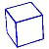
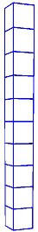

Place Value

Blank 120 Chart

Number order cards

18 | 20 | 2
12 | 7 | 0
4 | 19 | 6
17 | 10 | 14

Student Name: __________________________

First Grade Math Practice Log

Week Facts Facts Mastered
(Please check when facts are mastered.)

Week of June 3rd Adding 0

Week of June 10th Adding 1

Week of June 17th Adding 2

Week of June 24th Adding 3

Week of July 1st Adding 3

Week of July 8th Adding 4

Week of July 15th Adding 4

Week of July 22nd Adding 5

***Please return this sheet with the summer packet.***

Facts to Sums of 10

0 + 1 | 1 + 1 | 2 + 1 | 3 + 1 | 4 + 1
0 + 2 | 1 + 2 | 2 + 2 | 3 + 2 | 4 + 2
0 + 3 | 1 + 3 | 2 + 3 | 3 + 3 | 4 + 3
0 + 4 | 1 + 4 | 2 + 4 | 3 + 4 | 4 + 4
0 + 5 | 1 + 5 | 2 + 5 | 3 + 5 | 4 + 5
0 + 6 | 1 + 6 | 2 + 6 | 3 + 6 | 4 + 6

Facts to Sums of 10

5+ 1 | 6 + 1 | 7 + 1 | 8 + 1 | 9 + 1
5 + 2 | 6 + 2 | 7 + 2 | 8 + 2 | 0 + 7
5 + 3 | 6 + 3 | 7 + 3 | 1 + 7 | 0 + 8
5 + 4 | 6 + 4 | 2 + 7 | 1 + 8 | 0 + 9
5 + 5 | 3 + 7 | 2 + 8 | 1 + 9 | 0 + 10

Summer Walk
Go for a walk. Count the number of vehicles you see. Put them in categories (ex. Cars, Trucks, SUVs, etc.). Use the graph provided to chart your findings in your journal.

Number your paper 1 – 5. Answer the following questions (Write an equation to show how you got your answer.):
- How many cars and trucks did you find in all?
- How many SUVs and motorcycles did you find in all?
- Which vehicle had the greatest number?
- Which vehicle had the least number?

Summer Walk Graph
Color in a box for each car, truck, SUV, or motorcycle you saw on your walk.

Cars Trucks SUVs Motorcycles

Story Problems:

Cut out the 4 addition word problems and 8 subtraction word problems attached on the following page. Glue each word problem in your summer journal. Draw a picture and write an equation to show how you solved each word problem. Please follow the example below.

* Supports:
MCC1.OA.1: Use addition and subtraction within 20 to solve word problems involving situations of adding to, taking from, putting together, taking apart, and comparing with unknowns in all positions.

SEE EXAMPLE BELOW:

Read it.  Cut and glue down the story problem.  There are 14 horses. 7 horses gallop away. How many horses are left? | Draw the picture.  ø ø ø ø ø ø ø  0 0 0 0 0 0 0
Solve the problem.  14-7=7 | Write the answer.  7 horses  _________ ____________________  Number word (label)

Addition and Subtraction Word Problems

Lex eats 4 red grapes. He eats 2 green grapes. How many grapes does he eat in all? | There are 6 green frogs on a log. 3 more frogs hop onto the log. How many frogs are now on the log?
Jack has 7 pennies. She gives 3 pennies to her friend. How many pennies does Lisa have now? | Kim has 8 cookies. She eats 5 of the cookies. How many cookies does Kim have left?

